**Jenny'S - E-commerce Website**  

**Name:** Shivam **Course Name:** Full Stack Web Development  
**Instructor's Name:   
Submission Date:**

**Introduction:** Jenny's is an e-commerce website that aims to offer users a seamless shopping experience. The main objective of this project is to create a user-friendly platform where customers can browse products and add them to a shopping cart. The project employs modern web development technologies to ensure responsiveness, functionality, and an attractive interface.

**Project Structure:** There is a folder named "E-commerce Site" which contains all my files. Inside this folder is an "Images" folder where all the images used on the site are stored with corresponding names.

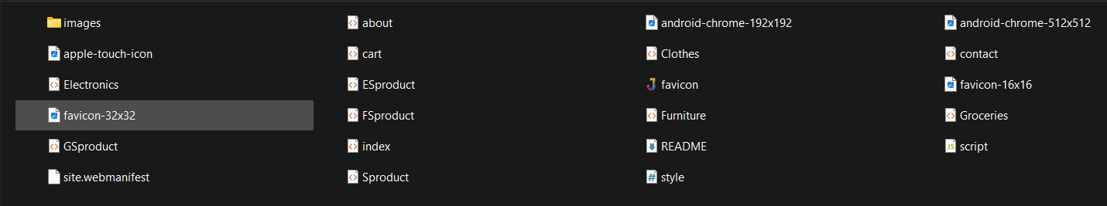

**Technical Stack:**

* Programming Languages:
* HTML



* CSS



* JavaScript



**Features and Functionalities:**

* Product Catalog: Display products with details, such as price, description, and images.
* Shopping Cart: Add or remove products from the cart, view cart items, and update quantities.
* Search & Filter: Search for products and filter by categories, etc.
* Responsive Design: Optimized for both desktop and mobile devices.
* Separate page: Every first product on a page has a descriptive page. Clicking on it will take you to the individual product page. On this page, I have used JavaScript to display photos. When you click on a small photo, it will replace the larger one.
* Calculation: I have used JavaScript for all the calculations. It displays the total amount of all the products listed in the cart.
* Navigation Menu: On mobile screens, there is a navigation button when you click on it navigation bar occurs, revealing the other categories of the products.

**Screenshots & Visuals:**

* Home Page:
* For Desktop: 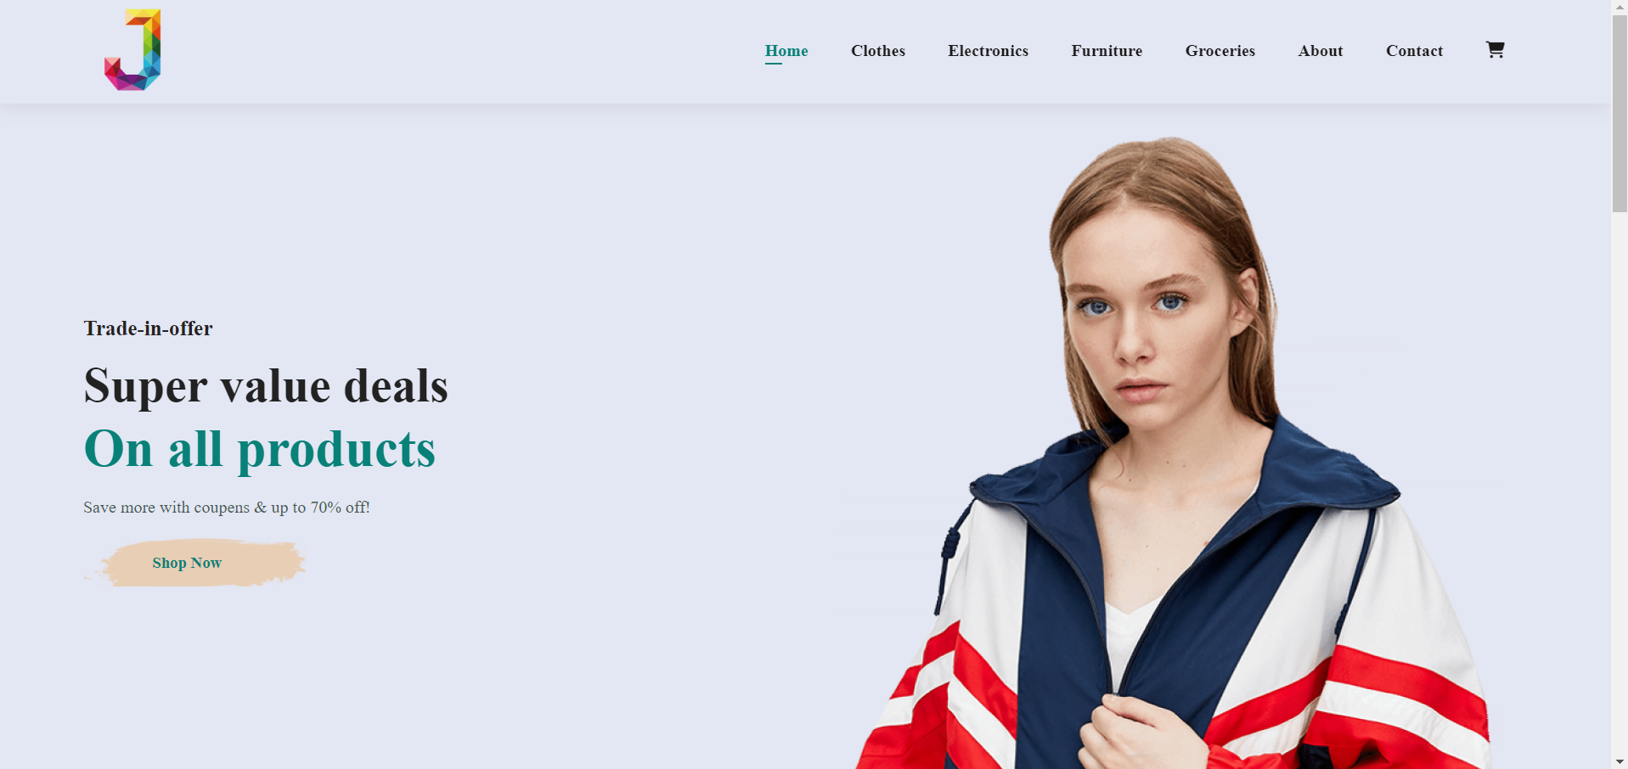
* For Mobile:

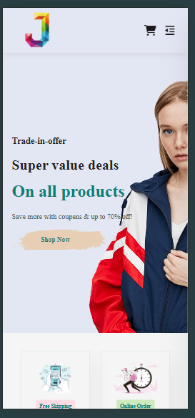

* Product Page: 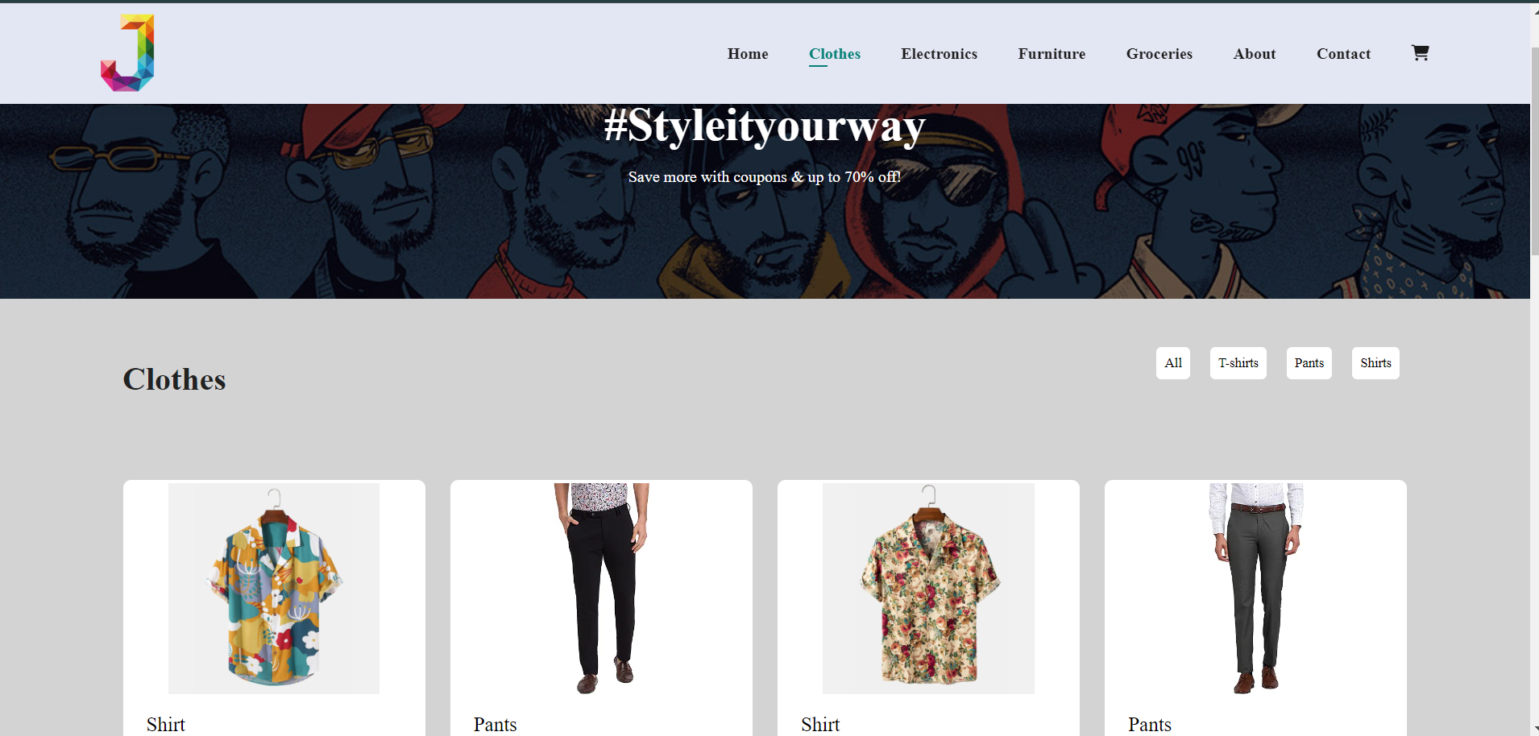
* Cart Page: 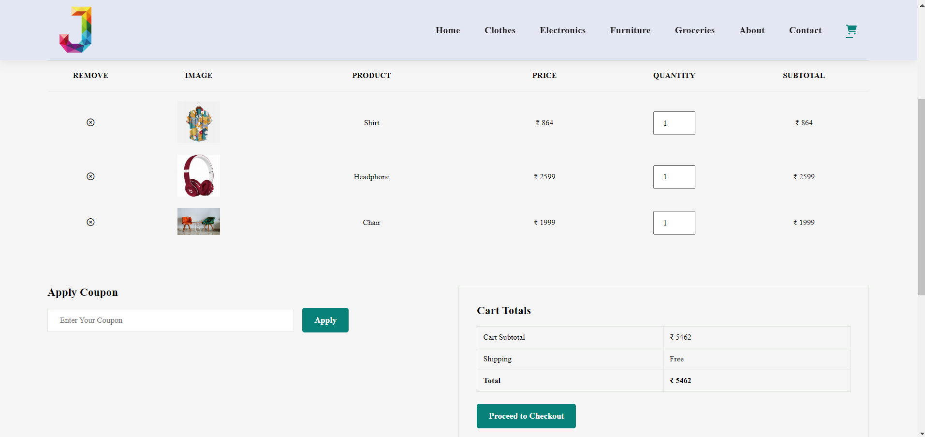

**Challenges Faced:**

* Data-id Overlap: Addressed overlapping ‘data-id’ attributes by ensuring unique identifiers for war products on different pages.
* Responsive Design: Ensured the website was fully responsive by using media queries and flexible grid layouts.
* Cross-Browser Compatibility: The challenge is ensuring the website works consistently across different web browsers. The solution to this is to test the website on various browsers and use polyfills and vendor prefixes to handle browser-specific issues.